

**Computer Graphics Lab**

**Name:** Pratham Kandari

**Sap Id:** 500097663

**Batch:** 7

**Experiment -7**

Q:1. WAP to perform the polygon filling using flood fill, boundary fill, and Scan line filling algorithms.

Ans:

1. **Flood Fill:**

#include <GL/glut.h>

int ww = 600, wh = 500;

float bgCol[3] = {0.0, 0.0,0.0};

float intCol[3] = {1.0,0.0,0.0};

float fillCol[3] = {0.4,0.0,0.0};

void setPixel(int pointx, int pointy, float f[3])

{

glBegin(GL_POINTS);

glColor3fv(f);

glVertex2i(pointx,pointy);

glEnd();

glFlush();

}

void getPixel(int x, int y, float pixels[3])

{

glReadPixels(x,y,1.0,1.0,GL_RGB,GL_FLOAT,pixels);

}

void drawPolygon(int x1, int y1, int x2, int y2)

{

glColor3f(1.0, 0.0, 0.0);

glBegin(GL_POLYGON);

glVertex2i(x1, y1);

glVertex2i(x1, y2);

glVertex2i(x2, y2);

glVertex2i(x2, y1);

glEnd();

glFlush();

}

void display()

{

glClearColor(0.2, 0.4,0.0, 1.0);

glClear(GL_COLOR_BUFFER_BIT);

drawPolygon(150,250,200,300);

glFlush();

}

void floodfill4(int x,int y,float oldcolor[3],float newcolor[3])

{

float color[3];

getPixel(x,y,color);

if(color[0]==oldcolor[0] && (color[1])==oldcolor[1] && (color[2])==oldcolor[2])

{

setPixel(x,y,newcolor);

floodfill4(x+1,y,oldcolor,newcolor);

floodfill4(x-1,y,oldcolor,newcolor);

floodfill4(x,y+1,oldcolor,newcolor);

floodfill4(x,y-1,oldcolor,newcolor);

}

}

void mouse(int btn, int state, int x, int y)

{

if(btn==GLUT_LEFT_BUTTON && state == GLUT_DOWN)

{

int xi = x;

int yi = (wh-y);

floodfill4(xi,yi,intCol,fillCol);

}

}

void myinit()

{

glViewport(0,0,ww,wh);

glMatrixMode(GL_PROJECTION);

glLoadIdentity();

gluOrtho2D(0.0,(GLdouble)ww,0.0,(GLdouble)wh);

glMatrixMode(GL_MODELVIEW);

}

int main(int argc, char** argv)

{

glutInit(&argc,argv);

glutInitDisplayMode (GLUT_SINGLE | GLUT_RGB);

glutInitWindowSize(ww,wh);

glutCreateWindow("Flood-Fill-Recursive");

glutDisplayFunc(display);

myinit();

glutMouseFunc(mouse);

glutMainLoop();

return 0;

}

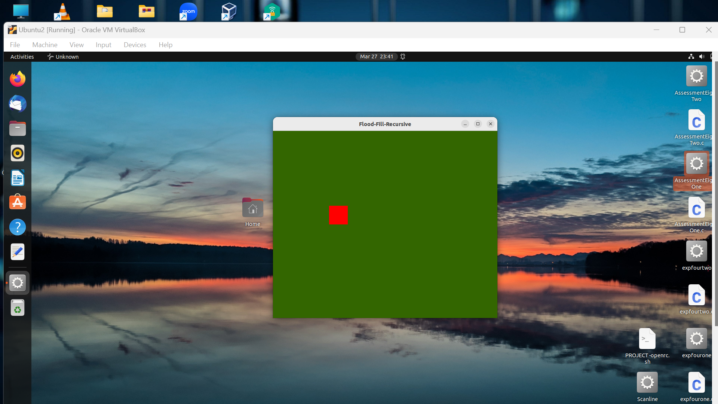

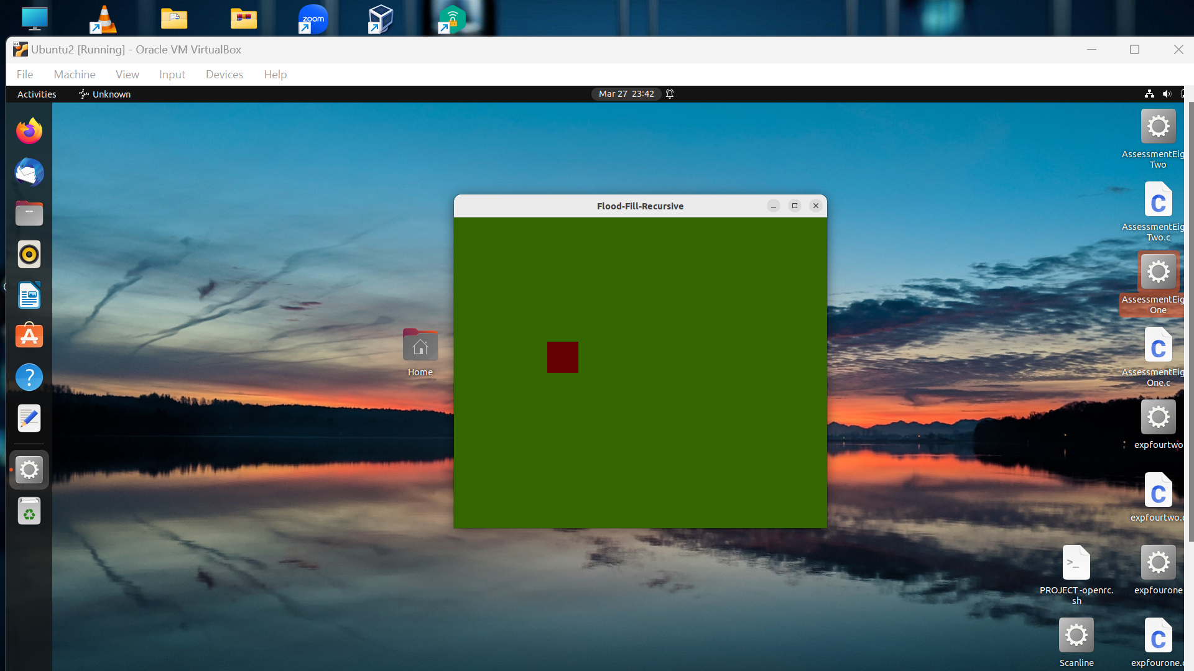

1. **Boundary Fill:**

#include <GL/glut.h>

int ww = 600, wh = 500;

float fillCol[3] = {0.4,0.0,0.0};

float borderCol[3] = {0.0,0.0,0.0};

void setPixel(int pointx, int pointy, float f[3])

{

glBegin(GL_POINTS);

glColor3fv(f);

glVertex2i(pointx,pointy);

glEnd();

glFlush();

}

void getPixel(int x, int y, float pixels[3])

{

glReadPixels(x,y,1.0,1.0,GL_RGB,GL_FLOAT,pixels);

}

void drawPolygon(int x1, int y1, int x2, int y2)

{

glColor3f(0.0,0.0,0.0);

glBegin(GL_LINES);

glVertex2i(x1, y1);

glVertex2i(x1, y2);

glEnd();

glBegin(GL_LINES);

glVertex2i(x2, y1);

glVertex2i(x2, y2);

glEnd();

glBegin(GL_LINES);

glVertex2i(x1, y1);

glVertex2i(x2, y1);

glEnd();

glBegin(GL_LINES);

glVertex2i(x1, y2);

glVertex2i(x2, y2);

glEnd();

glFlush();

}

void display()

{

glClearColor(0.6,0.8,0.1, 1.0);

glClear(GL_COLOR_BUFFER_BIT);

drawPolygon(150,250,200,300);

glFlush();

}

void boundaryFill4(int x,int y,float fillColor[3],float borderColor[3])

{

float interiorColor[3];

getPixel(x,y,interiorColor);

if((interiorColor[0]!=borderColor[0] && (interiorColor[1])!=borderColor[1] && (interiorColor[2])!=borderColor[2]) && (interiorColor[0]!=fillColor[0] && (interiorColor[1])!=fillColor[1] && (interiorColor[2])!=fillColor[2]))

{

setPixel(x,y,fillColor);

boundaryFill4(x+1,y,fillColor,borderColor);

boundaryFill4(x-1,y,fillColor,borderColor);

boundaryFill4(x,y+1,fillColor,borderColor);

boundaryFill4(x,y-1,fillColor,borderColor);

}

}

void mouse(int btn, int state, int x, int y)

{

if(btn==GLUT_LEFT_BUTTON && state == GLUT_DOWN)

{

int xi = x;

int yi = (wh-y);

boundaryFill4(xi,yi,fillCol,borderCol);

}

}

void myinit()

{

glViewport(0,0,ww,wh);

glMatrixMode(GL_PROJECTION);

glLoadIdentity();

gluOrtho2D(0.0,(GLdouble)ww,0.0,(GLdouble)wh);

glMatrixMode(GL_MODELVIEW);

}

int main(int argc, char** argv)

{

glutInit(&argc,argv);

glutInitDisplayMode (GLUT_SINGLE | GLUT_RGB);

glutInitWindowSize(ww,wh);

glutCreateWindow("Bountry-Fill-Recursive");

glutDisplayFunc(display);

myinit();

glutMouseFunc(mouse);

glutMainLoop();

return 0;

}

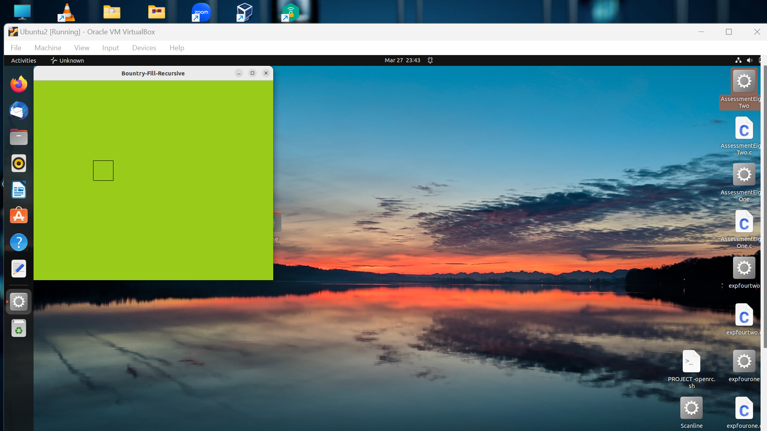

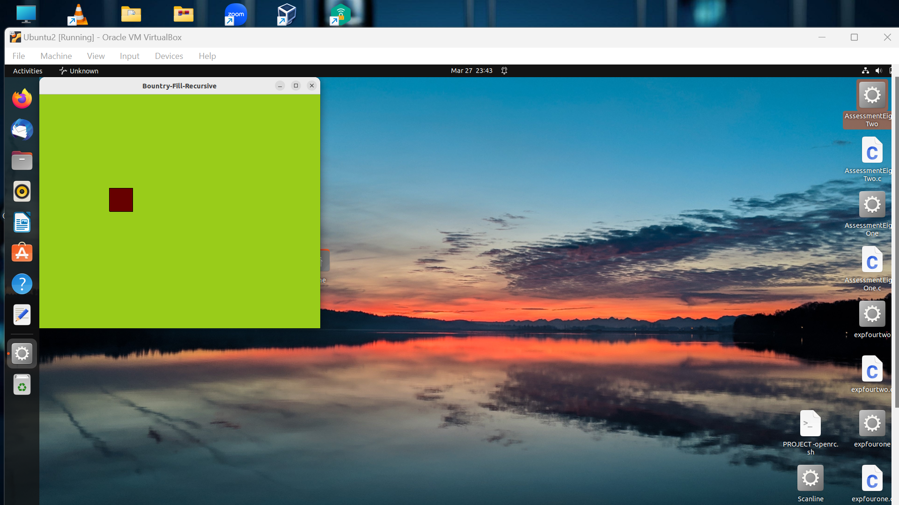

1. **Scan Fill:**

#include<GL/glut.h>

float x1,x2,x3,x4,y5,y2,y3,y4;

void draw_pixel(int x,int y)

{

glColor3f(0.0,1.0,1.0);

glPointSize(1.0);

glBegin(GL_POINTS);

glVertex2i(x,y);

glEnd();

}

void edgedetect(float x1,float y5,float x2,float y2,int *le,int *re)

{

float temp,x,mx;

int i;

if(y5>y2)

{

temp=x1,x1=x2,x2=temp;

temp=y5,y5=y2,y2=temp;

}

if(y5==y2)

mx=x2-x1;

else

mx=(x2-x1)/(y2-y5);

x=x1;

for(i=(int)y5;i<=(int)y2;i++)

{

if(x<(float)le[i]) le[i]=(int)x;

if(x>(float)re[i]) re[i]=(int)x;

x+=mx;

}

}

void scanfill(float x1,float y5,float x2,float y2,float x3,float y3,float x4,float y4)

{

int le[500],re[500],i,j;

for(i=0;i<500;i++)

le[i]=500,re[i]=0;

edgedetect(x1,y5,x2,y2,le,re);

edgedetect(x2,y2,x3,y3,le,re);

edgedetect(x3,y3,x4,y4,le,re);

edgedetect(x4,y4,x1,y5,le,re);

for(j=0;j<250;j++)

{

if(le[j]<=re[j])

for(i=le[j];i<re[j];i++)

draw_pixel(i,j);

}

}

void display()

{

x1=250.0;y5=200.0;x2=150.0;y2=300.0;x3=250.0;

y3=400.0;x4=350.0;y4=300.0;

glClear(GL_COLOR_BUFFER_BIT);

glColor3f(0.0,0.0,1.0);

glBegin(GL_LINE_LOOP);

glVertex2f(x1,y5);

glVertex2f(x2,y2);

glVertex2f(x3,y3);

glVertex2f(x4,y4);

glEnd();

scanfill(x1,y5,x2,y2,x3,y3,x4,y4);

glFlush();

}

void init()

{

glClearColor(1.0,1.0,1.0,1.0);

glMatrixMode(GL_PROJECTION);

glLoadIdentity();

gluOrtho2D(0.0,499.0,0.0,499.0);

}

void main(int argc,char **argv)

{

glutInit(&argc,argv);

glutInitDisplayMode(GLUT_SINGLE|GLUT_RGB);

glutInitWindowSize(500,500);

glutCreateWindow("scanline");

glutDisplayFunc(display);

init();

glutMainLoop();

}

